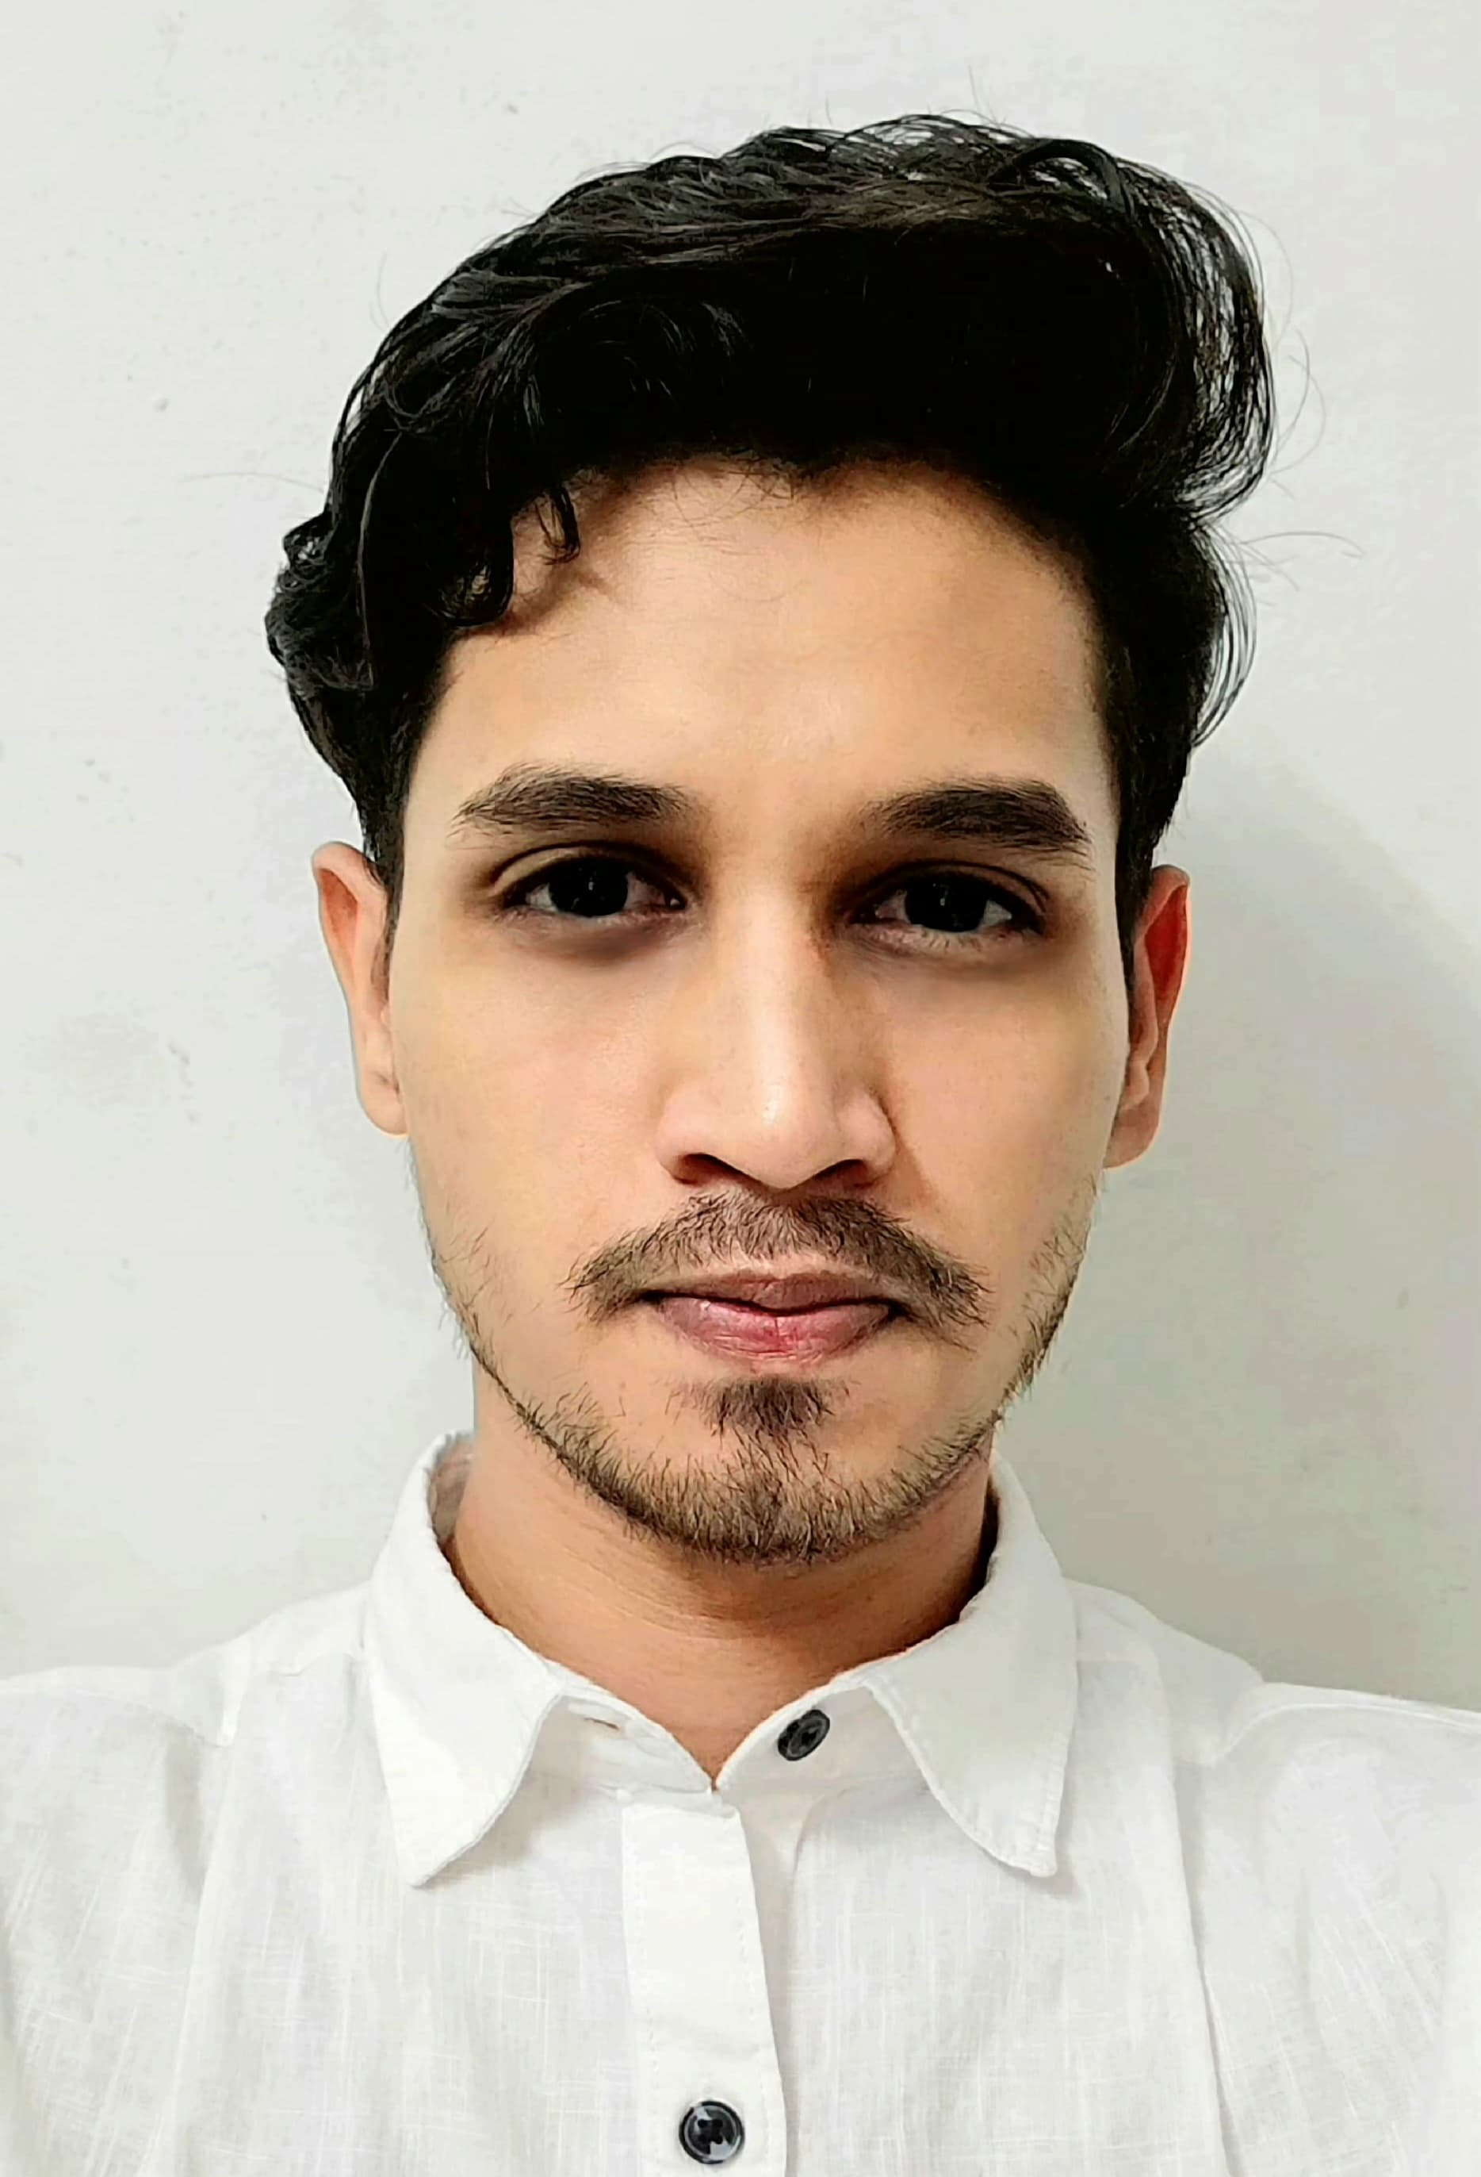  Profile  I am a confident communicator with a natural inclination for understanding and connecting with people, making it easy for others to relate to me. As an enthusiastic recent graduate, I am passionate about leveraging my skills in Python, SQL, JavaScript, Django, REST API, React, HTML, and CSS to drive innovation and deliver impactful solutions. I am eager to join a dynamic company where I can apply my diverse skill set, contribute fresh ideas, and support the company's growth. Let's connect to explore how I can add value to your team.  Contact  PHONE:  9608038689  WEBSITE:  LinkedIn  EMAIL:  mdabudarda992@gmail.com  Hobbies  Playing Cricket  Reading Sayari  Riding bike  Listening motivational music | Md. Abu Darda  Full Stack Developer (Fresher)  EDUCATION  - 2016-2017: Schooling from V.J International School, CBSE, Delhi  - 2017-2019: Intermediate at K.M College, Asarganj, BSEB, Patna  - 2021-2024: Bachelor’s Degree, Tilka Manjhi Bhagalpur University, BSEB, Patna  CERTIFICATES  - IT Vedant: Python/Django Development, Web-Design Essentials, SQL Foundation  - Hacker Rank: SQL Basics and Intermediate, Python Basic, ReactJS Basic  - IBM: Python Web Development  SKILLS  - Web Development: HTML, CSS, JavaScript  - Web Development: HTML, CSS, JavaScript  - Programming Languages: Python  - Frameworks: Django  - Databases: MySQL  Projects  E-commerce Management— HTML CSS Django and SQLite  - Revolutionized user registration with email verification and facilitated a captivating product browsing experience.  - Seamlessly integrated Razor pay’s payment gateway for secure transactions, enhancing customer trust and satisfaction.

